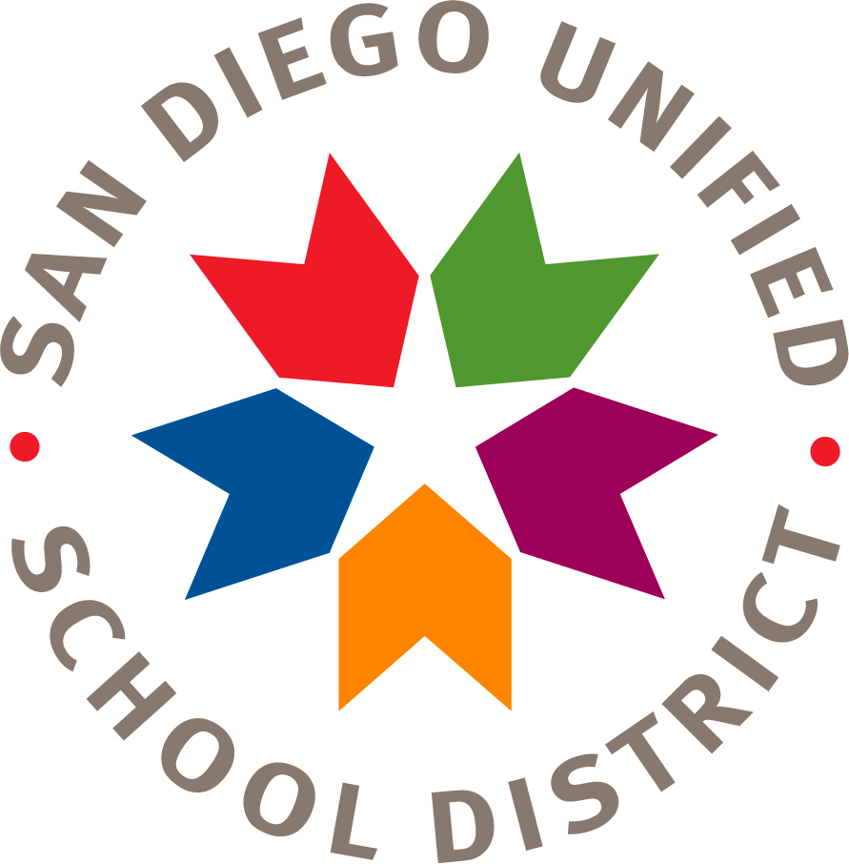
San Diego Unified School District
Financial Planning and Development
Financial Planning, Monitoring and Accountability Department

[Enter School Name]

Annual Title I Parent Meeting
Sample Agenda

- The Title I Program:
Title I is a K-12 program that provides additional academic support and learning opportunities for students at schools with high percentages of socioeconomically disadvantaged children. The program is intended to help ensure that all students meet challenging state academic standards. The goal of Title I is to provide direct instructional support to students and professional development for teachers, in addition to promoting parent education and involvement.

- Parent Rights under Title I law, parents have the right to:
  - Ask for their own meetings and trainings
  - Review the results of an annual parent involvement effectiveness survey
  - Review the school’s achievement data to determine if Title I services are effective in meeting the goals for student proficiency in state standards
  - Review the parent involvement plan in the Single Plan for Student Achievement (SPSA)
  - Review and modify the site Title I Parent & Family Engagement Policy and School Parent Compact

- Parent Involvement at Our School:
The School Site Council (SSC) provides parents with the opportunity to be involved in the academic program of the school. The SSC develops, monitors, and evaluates the Single Plan for Student Achievement (SPSA); implement programs and services that support students.
(Describe other opportunities for parent involvement at your site, such as PTA/PTO, a school foundation, parent meetings and trainings, a Parent Center on your campus, etc.)

- School Achievement Data:
Schools analyze and review schoolwide performance data, as well as the English Language Assessments for California (ELPAC) and graduation rates for high schools. They use the data to align the curriculum to state and district academic standards and adjust their instructional practices based on the findings of the assessment data.
(Provide parents with the most current data, and explain how the data were used to develop the goals and strategies in the Single Plan for Student Achievement.)

- Single Plan for Student Achievement:
Parents should receive information about the school’s curriculum, specifically the English/Language Arts and Math programs, and the assessments used to measure student progress in those programs.
(Discuss the goals and planned strategies of the school site plan.)

- Title I Expenditures:
Schools are allocated Title I funds based upon the percentage of students receiving free or reduced-price lunch. Schools in the San Diego Unified School District receive Title I funds if 40 percent (40%) or more of the student population is eligible for the free or reduced-price lunch program. Schools in the San Diego Unified School District are ranked according to this percentage and receive a certain amount of Title I money per student. Title I funds must supplement, not supplant, district funding.
(Describe the Title I budget, the expenditures that have been allocated for the 2018-19 school year, and how the Title I funds support increased student achievement.)

- Site Title I Parent and Family Engagement Policy and School Parent Compact:
The site Title I Parent & Family Engagement Policy communicates how the school will involve parents in an organized, ongoing, and timely way in the planning, review, and improvement of the Title I program at the school. The School Parent Compact describes the responsibilities of the school, the parent, and the student for improved student achievement.
(Review your current Title I Parent & Family Engagement Policy and School Parent Compact, how it was developed, and how it is reviewed and revised as needed on an annual basis.)

